Experiment No. 3
SE (CSE) ROLL NO : 10937
Date of Implementation: 12-02-2026
Aim: Implement Data Pre-processing techniques in Python
Programming Language Used : Python
Upon completion of this experiment, students will be able to
CO2 : Apply various analysis and visualization techniques using modern tools on real-world data
 | Indicator |  | Poor |  | Average | Good
 | Timeline  Maintains submission deadline (2) |  | Submission not done (0) |  | One or More than One week late (1) | Maintains deadline (2)
 | Completion and Organization (2) |  | Many mistakes in documents (0) |  | Document is just acceptable (1) | Completed whole document and neatly organized (2)
 | Program Performance (2) |  | Could not perform at all (0) |  | Implemented few parts (1) | Full implementation (2)
 | Knowledge  In depth knowledge of the Experiment (4) |  | Unable to answer questions(0) |  | Unable to answer few questions (1-2) | Able to answer all questions with proper explanation (3-4)
Assessment Marks :
 | Timeline
 | Completion and Organization
 | Program Performance
 | Knowledge
TOTAL :

EXPERIMENT | 3
Aim | Implement Data Preprocessing techniques in Python
Theory | Data Cleaning  Data cleaning is the process of identifying and correcting errors, inconsistencies, and inaccuracies present in raw data.  Data Transformation  Data transformation converts cleaned data into a suitable format for analysis and modeling. It involves changing data types, scaling numerical values, and encoding categorical variables.  Data Integration  Data integration combines data from multiple sources into a single, consistent dataset. It is commonly required when data is collected from different systems or files.  Data Summarization  Data summarization provides a compact representation of data using statistical measures. Measures such as mean, median, standard deviation, and group-wise aggregates help in understanding central tendency and variability.  Feature Engineering  Feature engineering is the process of creating new meaningful features from existing data to improve analytical or predictive performance.
Implementation | - Handle Missing Values  - Replace missing Age with median age  - Replace missing Income with mean income  - Replace missing PurchaseAmount with 0  - Correct Invalid Values  Remove records where Age < 0 or Age > 100  - Standardize Categorical Values  - Convert Gender values to only Male and Female  - Convert ProductCategory to lowercase  - Remove Duplicate Records  Remove duplicate rows based on CustomerID  - Perform equal width binning on the Income attribute.  - Divide the Income attribute into 4 equal-width bins.  - Assign appropriate labels to each bin (Very Low, Low, Medium, High).  - Create a new feature named Income_EqualWidth.  - Plot a histogram showing the distribution of customers across the equal-width bins.  - Perform Equal Frequency Binning  - Divide the Income attribute into 4 equal-frequency bins.  - Assign labels (Q1, Q2, Q3, Q4).  - Create a new feature named Income_EqualFrequency. Plot a bar chart showing the number of customers in each bin  - Outlier detection  - Compute Z-scores for PurchaseAmount.

- Identify records with Z-score > 3 or < −3.
- Display the outlier records.
- Remove outliers and recompute the mean.
- Data Type Conversion
Convert Income from string to float
- Normalization
Normalize Age and Income using Min–Max scaling
- Dataset Integration
Perform inner join on CustomerID (Drop orphan purchase records automatically)
- Feature Creation
Create a new feature HighSpender (Mark 1 if PurchaseAmount > average, else 0)
- OLAP operations
  - Perform slice operation to get total and average purchase amount for Female customers only.
  - Perform dice operation for: Gender = Male, ProductCategory = Electronics. Display number of purchases and average PurchaseAmount
  - Perform roll-up operation to compute total purchase amount by Gender.
  - Perform drill down operation. Analyze purchase amount by Gender and ProductCategory.
- Apply one hot encoding to gender column. Add encoded columns to data set. Drop original gender column
Conclusion | This experiment demonstrates the importance of preprocessing steps in the data analytics pipeline. Properly cleaned and processed data significantly improves the quality and reliability of analytical and predictive models.
Post Lab Questions: | - What is the difference between pivot_table command and group by command?  - What are orphan records?  - What is dummy variable trap?

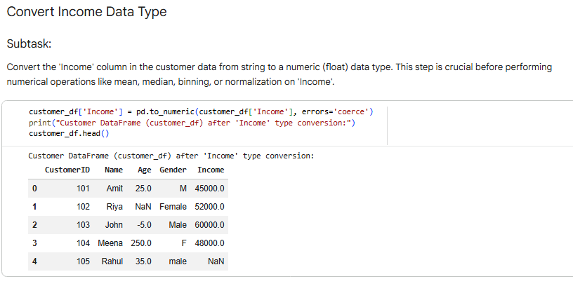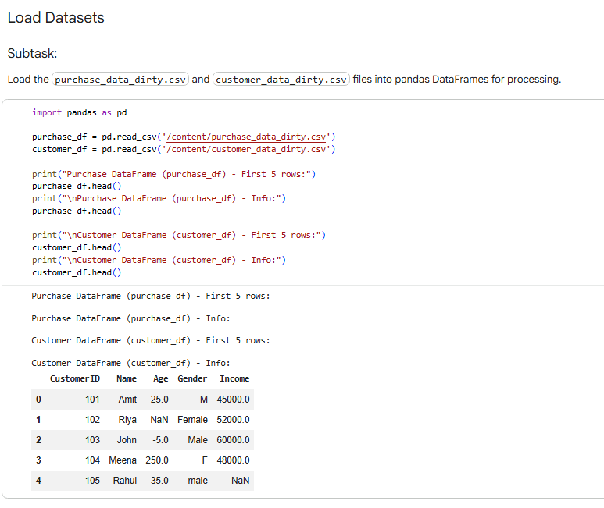

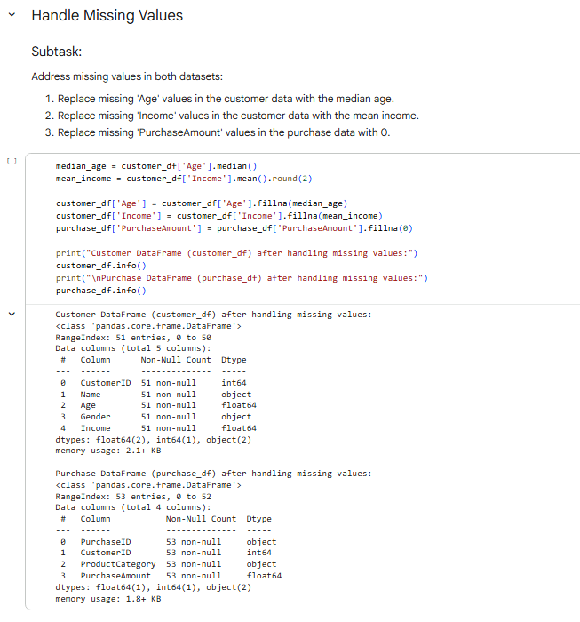

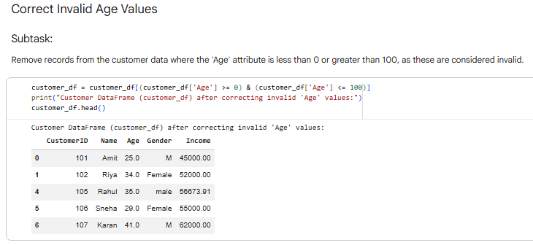

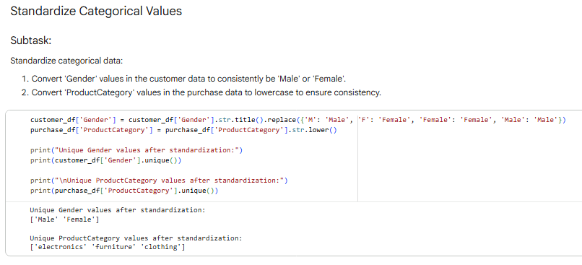

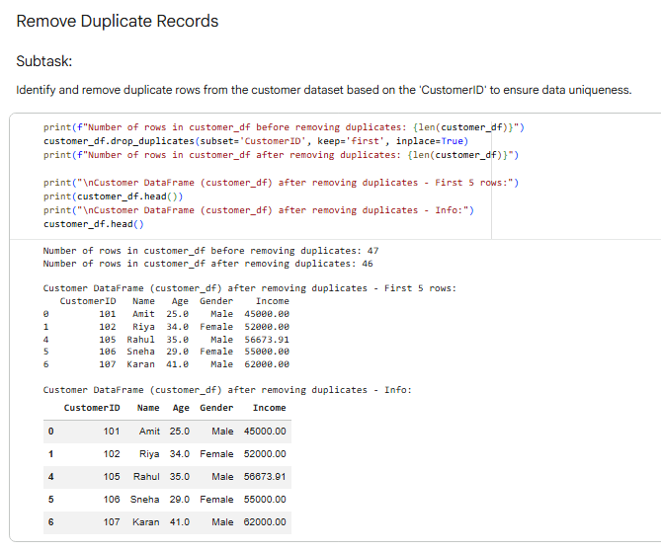

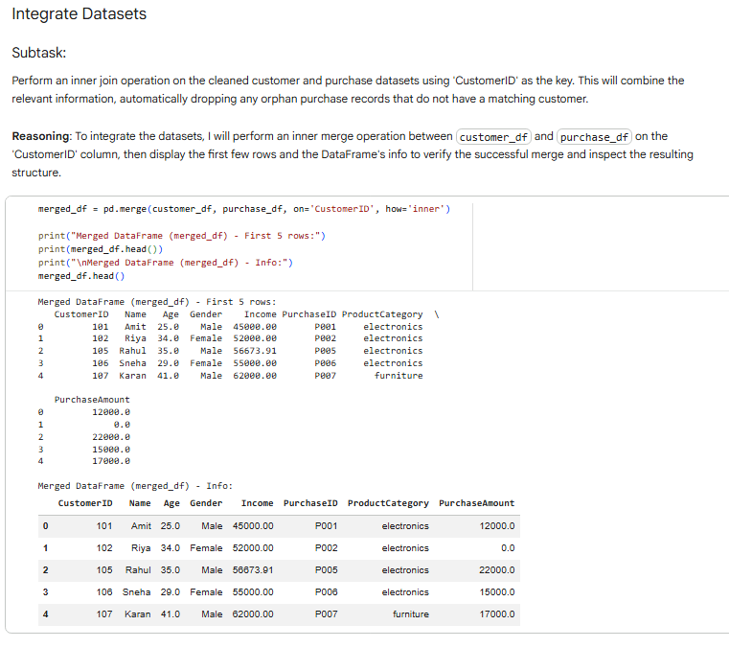

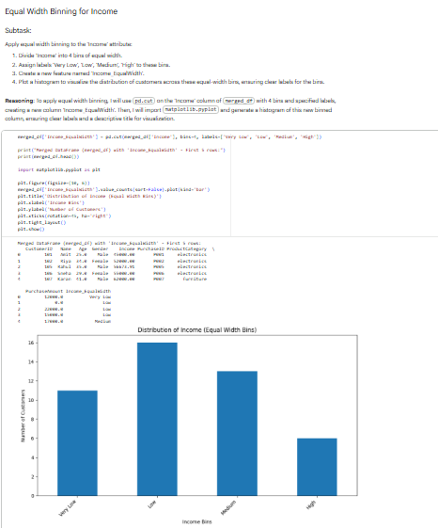
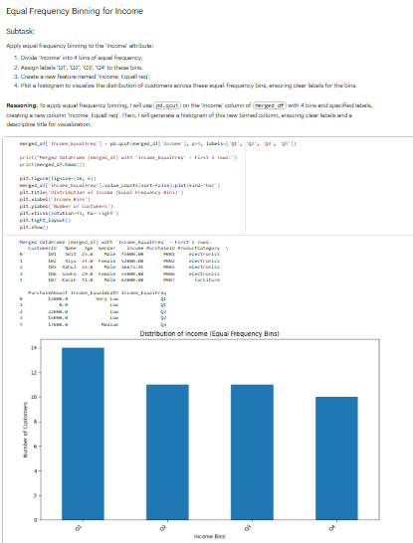

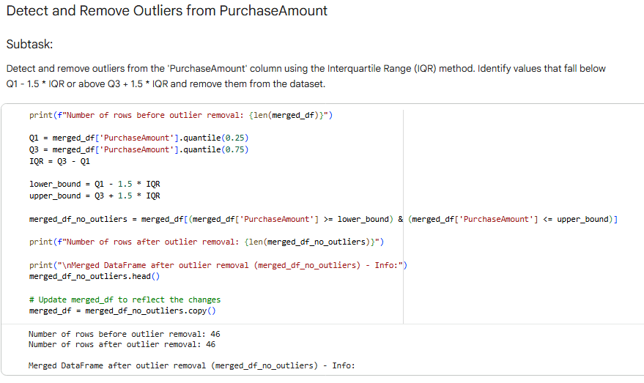

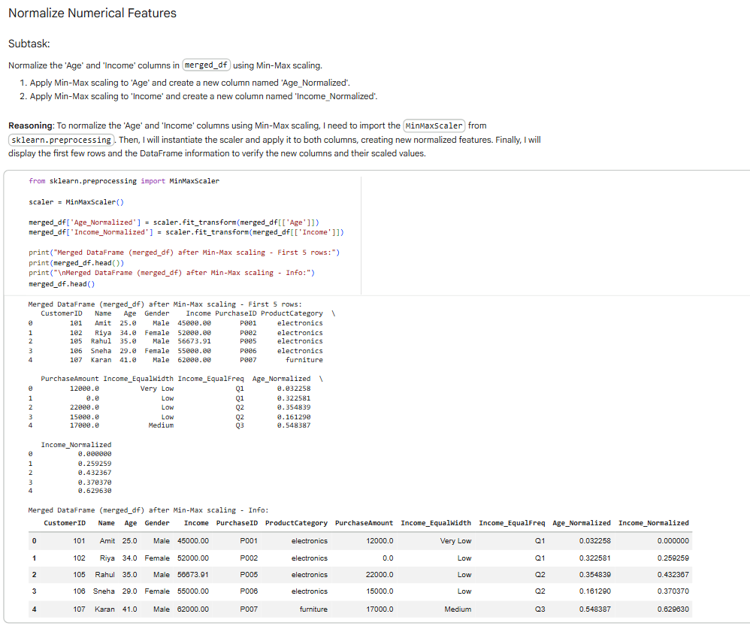
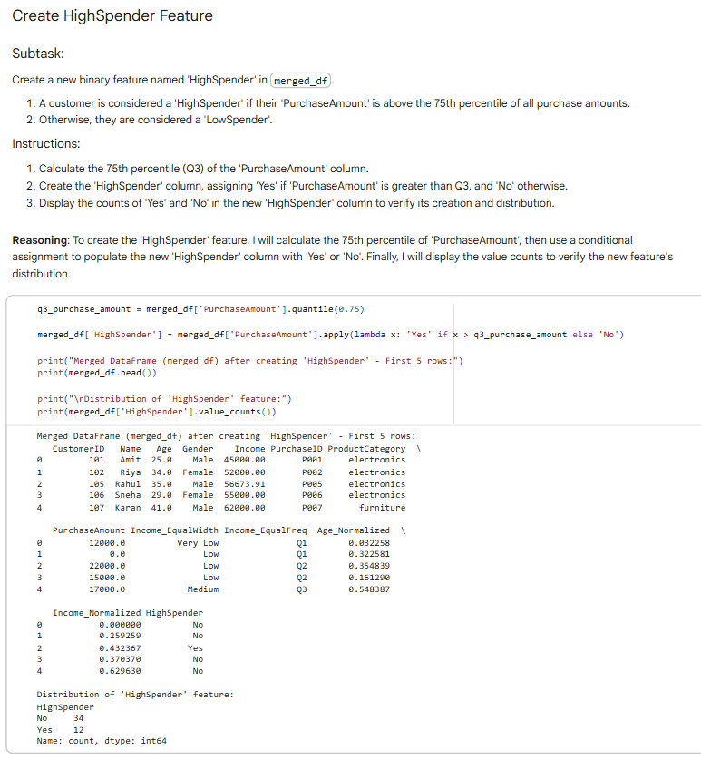
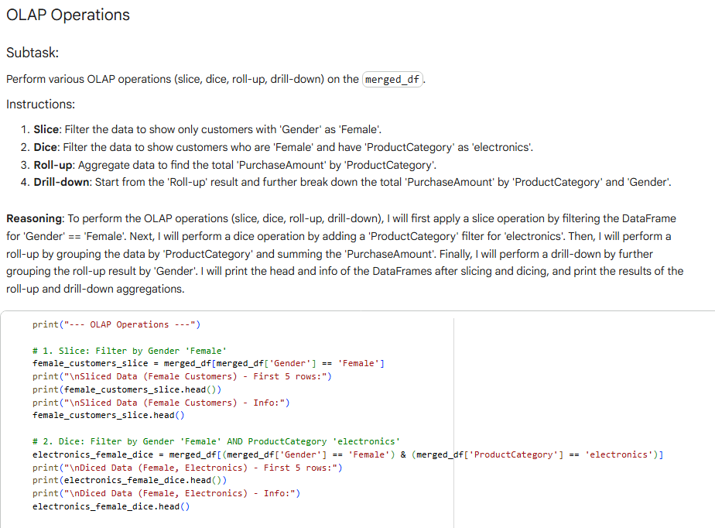

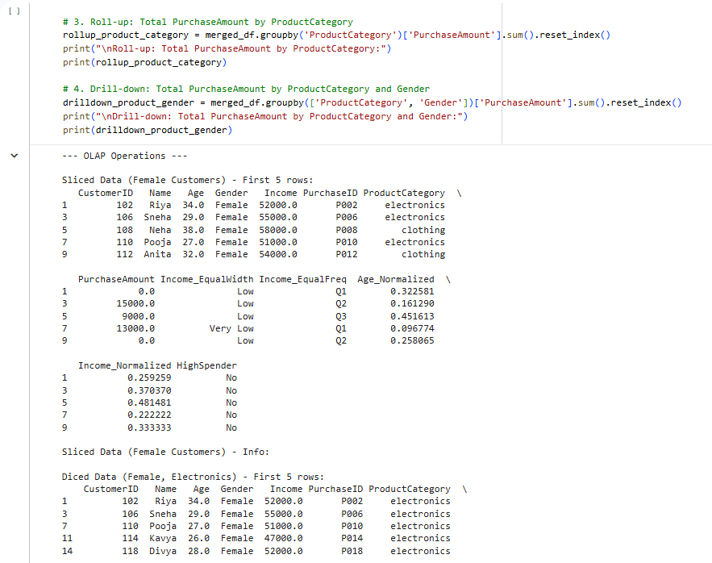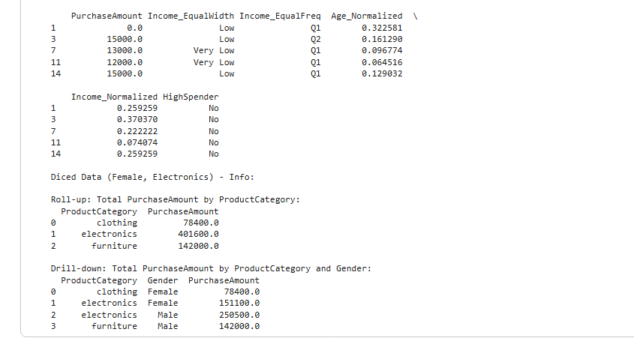

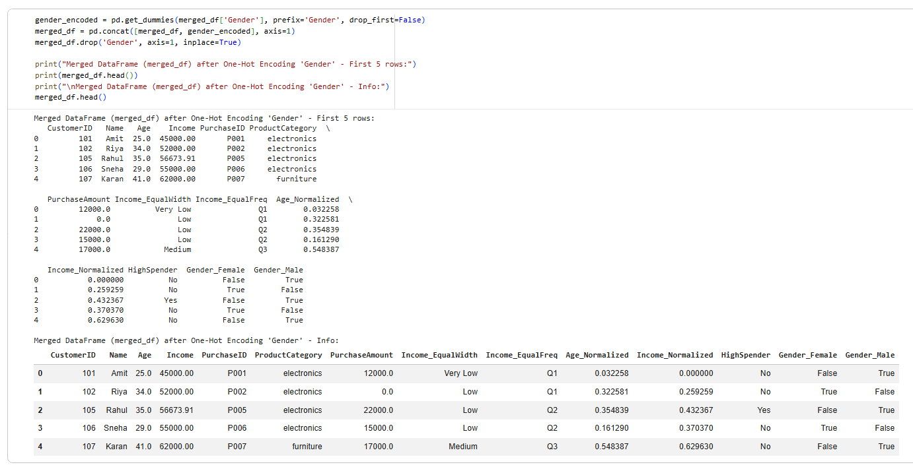

Post Lab Questions:
- What is the difference between pivot_table command and group by command?
Sol.
groupby() | pivot_table()
Group data and apply aggregation | Reshape + aggregate data into a spreadsheet-style table
Usually long format | Cross-tabulated (matrix) format
Required explicitly | Built-in aggregation parameter
Manual reshaping needed | Direct row/column grouping
Basic | Built-in fill_value, margins, etc.

- What are orphan records?
Sol. Orphan records are child table records that reference a parent record that does not exist.

- What is dummy variable trap?
Sol. The dummy variable trap occurs when dummy variables created for categorical data are highly correlated, making regression coefficients unstable.

